Excursion on continuous cover forestry in western Switzerland (Canton de Neuchâtel) April. 22th 2009

Historical Background
(emergence of the Check Method or Control Method and of the plentering system or selection system)
Together with the Great Duchy of Baden (Black Forest, Germany) and the Swiss Jura, the French region of Franche-Comté (including the departements of Doubs, Jura, Haute-Saône and the territory of Belfort, or simply «historical Burgundy») was one of the areas where irregular forest silviculture was pioneered from the late 19th century onwards. Franche-Comté is where the management method was born. Here, the so-called Control Method emerged (developed by A. Gurnaud, about 1880).
In this region, there was intense competition to devise new methods of forest management; this gave Adolphe Gurnaud (1825-1898) the impetus to come up with radical ideas that shook established thinking. At the root of the confrontation was the fact that Gurnaud challenged the established ideology of forest management, which used controlled areas and set rotation periods, and suggested using stand-specific criteria. According to Gurnaud, the treatment method (or rather, the rotation period) should no longer be considered as the indicator of stand development and treatment, but rather the increment. According to Gurnaud, it was the increment that should be at the forefront of a modern forest planning strategy that is both forward-looking and retrospective, based on constant monitoring (control). Forest management body to observe which direction the experimental forest treatment took.
So at the outset, the Control Method was seen as a new vision of forest management, and not as a new method of forest treatment. Not until later (around 1878) was it proven that this visionary method worked best in conjunction with the plentering treatment method. Henry Biolley (1858-1939) put this silvicultural dimension into practice and refined these «Control» ideas from 1889 onwards in the communal forest of Couvet (Switzerland).
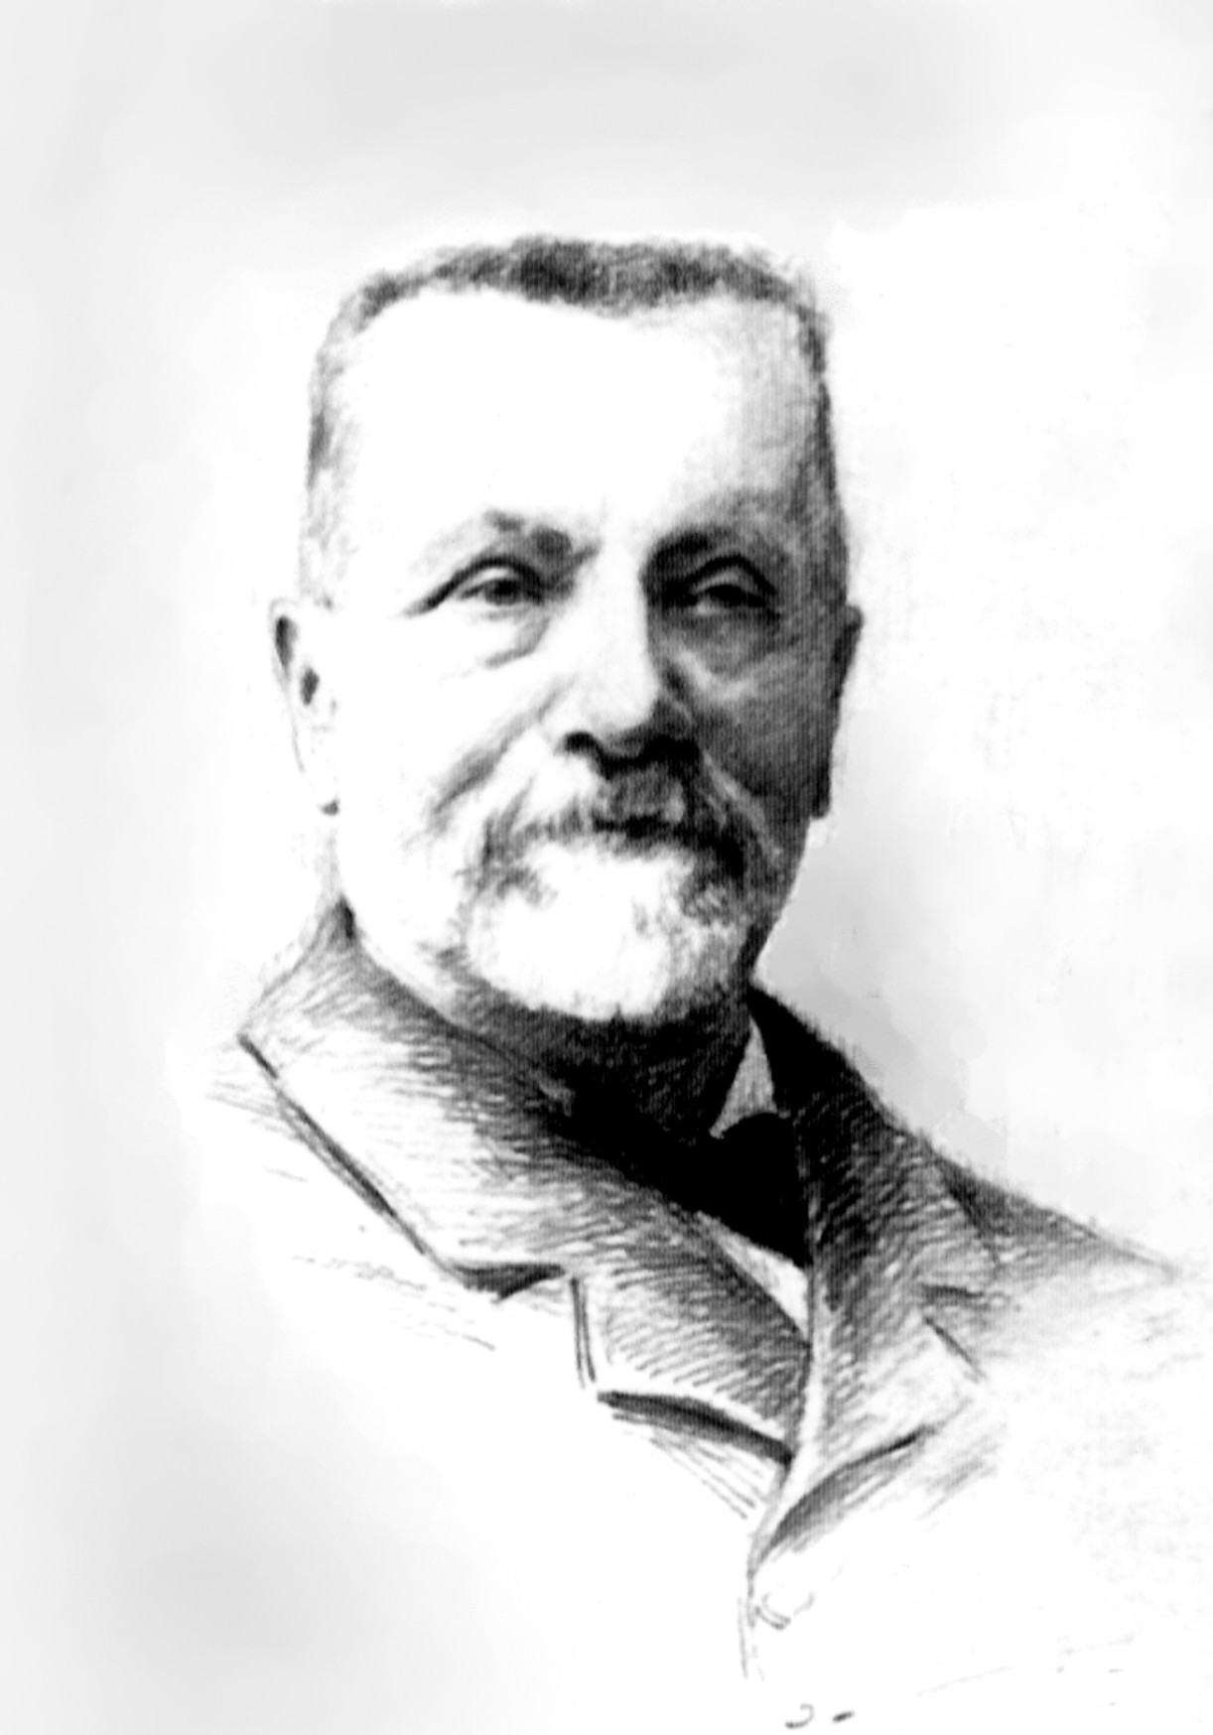
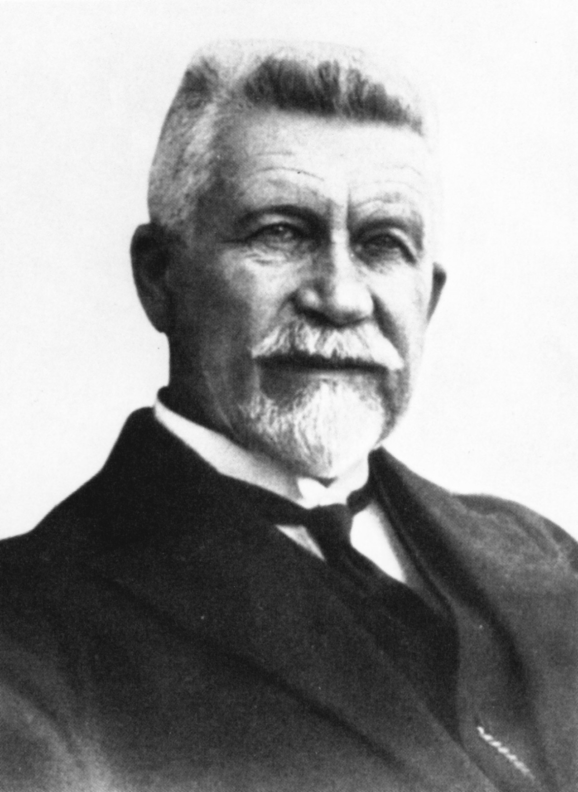

Adolphe Gurnaud (1825-1898) Henry Biolley (1858-1939)
At the time, this idea was so revolutionary that it met with much opposition. As in previous periods of change when new ideas were emerging, there was outspoken criticism, but also much intensive, positive emulation. At first, the Control Method was forcibly rejected by the French forest authorities. The idea was received more favourably in the neighbouring Swiss Jura, where Biolley introduced the method in 1889 (both in Couvet and in the privately-owned Les Erses forest), and then later used it as the standard method. Other supporters propagated these ideas with their own experimental evidence. One example of this was a group of Swiss and French foresters, followers of the Control Method, who carried out experiments in forests, specially purchased by the «Société du Contrôle» (formed in 1906); another example is the pioneer William Borel (1864-1944), who purchased the Les Erses forest (Switzerland) in order to carry out experiments.

Historical Background

(application in Switzerland)
The plentering system (classically known as single-stem selection forest management), that is, the very subtle mix of age classes was introduced in the Swiss Jura in 1881 as a model solution and has been applied more or less without interruption in various areas ever since. This was made possible by the visionary work of a few pioneers, such as Henry Biolley (Forest District Officer at Couvet, then Forest Manager of the canton of Neuchâtel) and William Borel (Forest Manager of the canton of Geneva and owner of the private forest Les Erses). In stark contrast to France, these new ideas were received much better here; where it has led to an exemplary experience of these forestry management techniques. The charisma, patience and persuasive powers of pioneers such as Biolley, Borel and others led to a wide acceptance of this “different” forest treatment method: in several areas, the Control Method and plentering system were adopted as the forest management method.
Biolley was first introduced to the Control Method at the World Exhibition in Paris in 1879, where it was expounded by Gurnaud in a self-published leaflet. The leaflet focused more on the principles of the new forest management method rather than on special forest treatment, as Gurnaud considered his method to be universally compatible. Biolley immediately realised how important it was to experiment (with the Control Method) and at the same time, to optimise all utilities within one single new forest management system. He understood the unique importance of the plentering system, the principles of which he presented clearly in publications in 1897 and 1901. He introduced these principles in the forests of his district and later all over the canton of Neuchâtel.
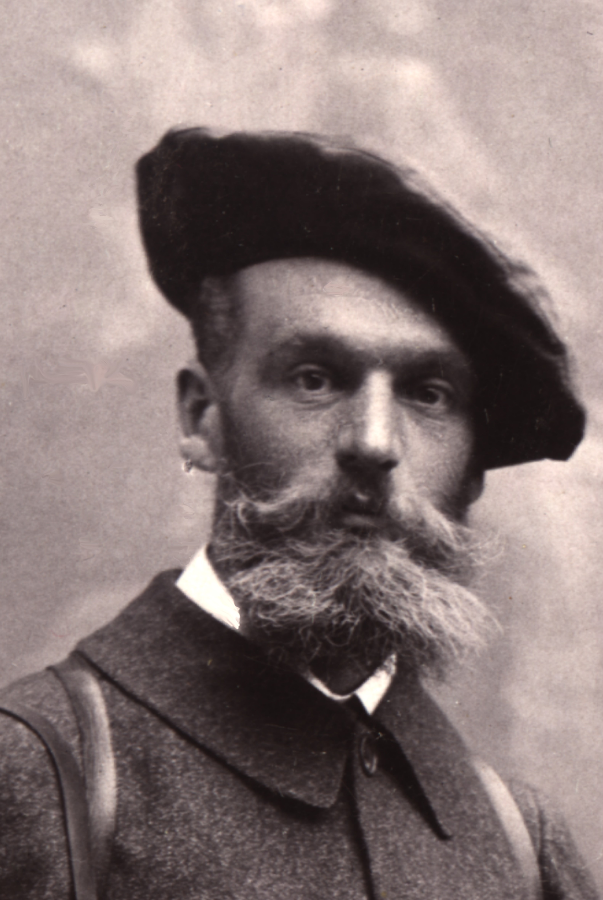
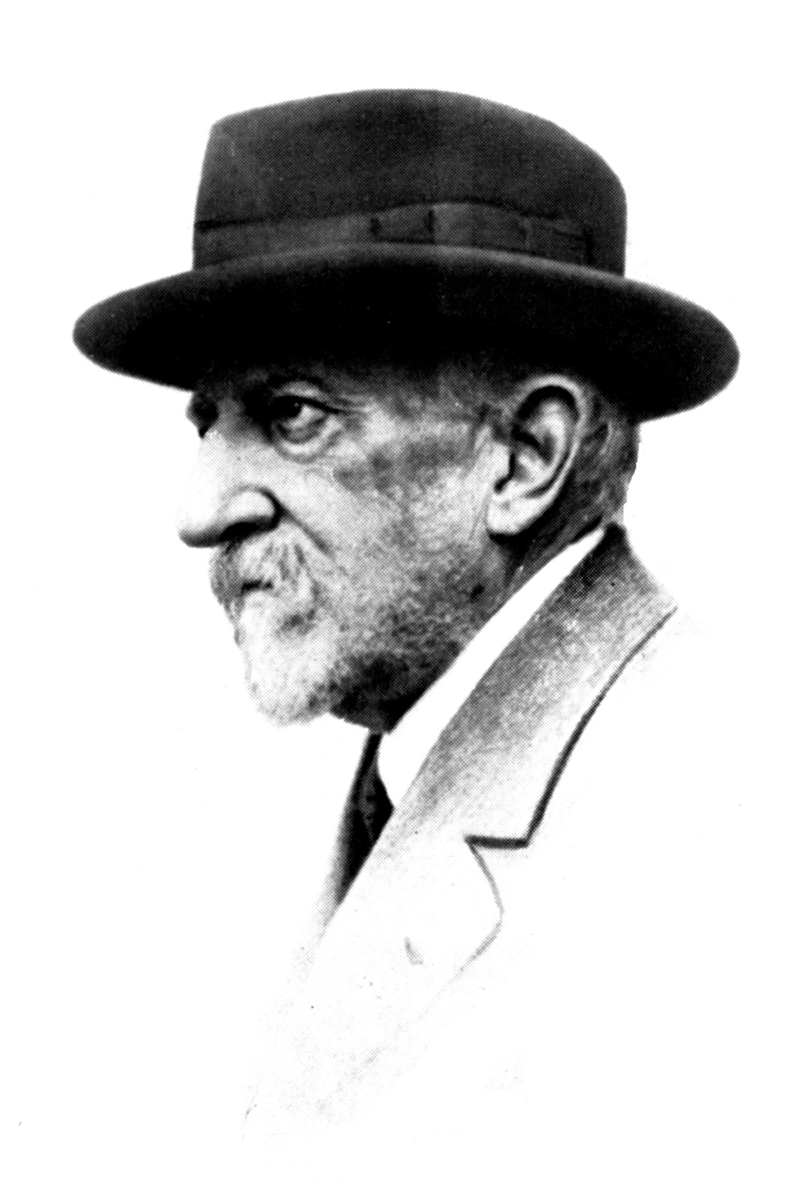

William Borel (1864-1944) André Schaeffer (1859 – 1932)

Founded in 1889, the Silvicultural Society of Franche-Comté (Société Forestière de Franche Comté) proved to be the embryo of this intellectual movement. This society is the oldest and most dynamic specialist silvicultural organisation in France. Due to the fact that they also issued publications (still in existence), these new ideas were spread through the medium of the Bulletin de la Société Forestière de Franche-Comté. All the key players in this extremely intensive movement are members of this society. Today, the society continues to disseminate these ideas. For example, it has recently played an important role in propagating the treatment of uneven forests by organising the first international convention for foresters working «near to nature» (Prosilva) in Besançon in 1994. Between 1996-2000, a network of reference areas was established, with the aim of documenting the differing facets of uneven mixed deciduous forest treatment. The society maintains that individual stand typology should be the basis for silvicultural decision making, as far as treatment methods are concerned. Together with forestry institutions, they launched the EU-LIFE Project on the sustainability of irregular broad-leaved forests.

The Control Society:
Society established in 1906 by key forestry players from Franche-Comté (France) (A. Gazin, F. de Liocourt, A. Schaeffer, H. Rimaud) and Switzerland (H. Biolley, W. Borel, A. Barbey), along with supporters of the Control Method (A. Jobez, P. Croizat, P. Bidot, P. Grea). They purchased the forest at Hautecour (64 ha), and later other forests where they applied the Control Method in its original form. Members meet annually. They create an inventory of the divisions due to be harvested, and together mark the silvicultural intervention.

Excursion to Couvet communal forest

Silvicultural goal: Since 1881 (when H. Biolley took office), the goal has been to gradually establish the single-stem plentering system, including a high percentage of coniferous trees and a target growing stock of about 350 m³/ha. This was to occur in an empirical fashion and supervised periodically by means of the Control Method. The combination of forest management and the Control Method (still applied now, most recent inventory in 2001) is at the same time a follow up as well as a certification, i.e. a control criterion for the suitability of the forest treatment. It aims to optimise sustainable structures in a step-by-step way.

Biolley was Forest District Officer of Val-de-Travers (the valley in which Couvet is located) from 1881 to 1917. Later, he was Forest Manager of the canton of Neuchâtel until 1927. Biolley lived in his parents’ house in Couvet until he died in 1939.

Stand evolution from 1890 to 2001 (i.e. 111 years) according to results of the Control Method:
Characteristics of the method :
- Full inventory at dbh-limit 17.5cm; 5 cm diameter categories
- Timber-size-classes:
PB (petit bois): small timber (categories 20, 25, 30)
BM (bois moyens): medium timber (35, 40, 45, 50)
GB (gros bois): large timber (more than 55)
- Note: The delimitation between timber-size classes differs from the one applied in France.
- Evolution of growing stock (standing volume) and volume increment from 1890 to 2001.
- Assessment of standing volume : using a so-called conventional, unique volume function (related to dbh). No difference between tree species. The volume function remains unchanged since the first survey. The ratio of standing volume to real (marketable) timber volume (including pulp and fuel timber at a timber limit of 7cm) varies from between 0.9 and 1.0.
- sv=m3 standing volume

Validity: working-class I north-western slope; increment of standing volume (corresponds approximately to marketable timber, above 7cm dbh). Increment in sv/ha/y (calculated as the difference between two inventories, taking into account the exploitation in between). For a more detailed interpretation, the increment results are subdivided into the tree timber-size-classes. In addition, the ingrowth increment (IG) corresponds to the volume of newcomers (young growth up to 17.5cm dbh). According to the Control Method, IG represents the volume increment of the un-inventoried part of the stand under consideration (below 17.5cm dbh). Note: Over recent periods, the increment has tended to increase. This phenomenon can be interpreted as a consequence of improving growing conditions.

Distribution of timber assortments (%)

Period | 1954/60 | 1984/91
Saw logs | 63.6 | 80.7
Industrial | 13.4 | 14.1
Fuel timber | 23.0 | 5.2

Division I/14, Communal forest of Couvet

At the start of the observation, Biolley stated that this division was one of the best structured stands. This allows us to document the evolution of stands in which the plentering system has been applied for over 100 years. In comparison, see Stop 2 (forest plot of the Wepfler family’s private forest ), where no silvicultural intervention has occurred over the last 50 years.

In 1890, Biolley described the stand in division I/14 as: "Irregular age-distribution of fir and spruce, generally in a fine mixture, although somewhat uneven. No bare parts except for some wet areas. Old growth has been exploited in recent years. Considerable young growth (sapling stage), in some places competing with blackthorn bush (Prunus spinosa) and other shrubs or low crown branches from remaining standards. In some parts of the upper storey, trees compete with each other and do not display a universal optimal stem quality (many of them are forked or attacked by the cancer Melampsorella caryophyllacearum)."

In division I/14, the standing volume was about 300 m³/ha at the outset. This means below the demographic equilibrium of standing volume which Biolley estimated to be about 350 m³/ha and which he later calculated to be 338 m³/ha, according to demographic equilibrium conditions (so-called dynamic equilibrium model, Schütz, 1975). This means that ingrowth of young trees was adequate, at least at that time.

The evolution of standing volume shows a gradual and gentle increase, peaking in 1975 (439 m³/ha). At the same time, we can see the consequences of large tree stockpiling: the proportion of GB (i.e. larger than 55 dbh) increased from 16.5% (1890) to 62.5% (1960). The ingrowth increment decreased dramatically (from 2.0 m³/ha/y in 1880 to 0.3 m³/ha/y in 1975), revealing that stockpiling had exceeded the equilibrium point. In fact, demographic equilibrium calculations (in this case, at an inventory limit of 17.5cm dbh) show that an ingrowth of at least 1.00 m³/ha/y is necessary to assure sustainability. After 1975, the standing volume decreased slowly.

The Wepfler family’s private forest (a relatively natural stand)

The site conditions are identical. This forest shows the evolution of untreated forest stands, that is, the evolution of the structure of natural forest under these ecological conditions (optimum conditions for Abies alba). This forest is privately owned, and no silvicultural intervention has occurred over the last 50 years.
In 2001, a profile survey of a 50 x 30 m plot was carried out in this private forest. The results are presented along with a profile of a typical plentering stand in the same region (Gauchat, 1967).
Structural differences between plentering forest and natural forest in the Couvet region

 | Native forest Wepfler Plot | Plentering forest Couvet, div. I/9
Standing volume | 997.4 m³/ha | 505.0 m³/ha
Basal area : | 78.9 m²/ha | 42.18 m²/ha

 | Wepfler plot | Couvet plot
small timber | 3 % | 9.4 %
medium timber | 15 % | 16.3 %
large timber | 83 % | 74.3 %

Wepfler plot Couvet plot Div. I/9

